# THE MACHINE LEARNING CANVAS Designed for: Designed by: Date: Iteration: .

|  |  |  |  |  |
| --- | --- | --- | --- | --- |
| PREDICTION TASKType of task? Entity on which predictions are made? Possible outcomes? Wait time before observation? | DECISIONSHow are predictions turned into proposed value for the end-user? Mention parameters of the process / application that does that. | VALUE PROPOSITIONWho is the end-user? What are their objectives? How will they benefit from the ML system? Mention workflow/interfaces. | DATA COLLECTIONStrategy for initial train set & continuous update. Mention collection rate, holdout on production entities, cost/constraints to observe outcomes. | DATA SOURCESWhere can we get (raw) information on entities and observed outcomes? Mention database tables, API methods, websites to scrape, etc. |
| IMPACT SIMULATIONCan models be deployed? Which test data to assess performance? Cost/gain values for (in)correct decisions? [Fairness constraint](https://developers.google.com/machine-learning/glossary#fairness-constraint)? | MAKING PREDICTIONSWhen do we make real-time / batch pred.? Time available for this + featurization + post-processing? Compute target? |  | BUILDING MODELSHow many prod models are needed? When would we update? Time available for this (including featurization and analysis)? | FEATURESInput representations available at prediction time, extracted from raw data sources. |
|  | MONITORINGMetrics to quantify value creation and measure the ML system’s impact in production (on end-users and business)? |  |  |  |

|  |  |  |
| --- | --- | --- |
|  | Version 1.1. Created by Louis Dorard, Ph.D. Licensed under a [Creative Commons Attribution-ShareAlike 4.0 International License](https://creativecommons.org/licenses/by-sa/4.0/). Please keep this mention and the link to [ownml.co](https://www.ownml.co/) when sharing. | [**OWNML.CO**](https://www.ownml.co/) |

# 

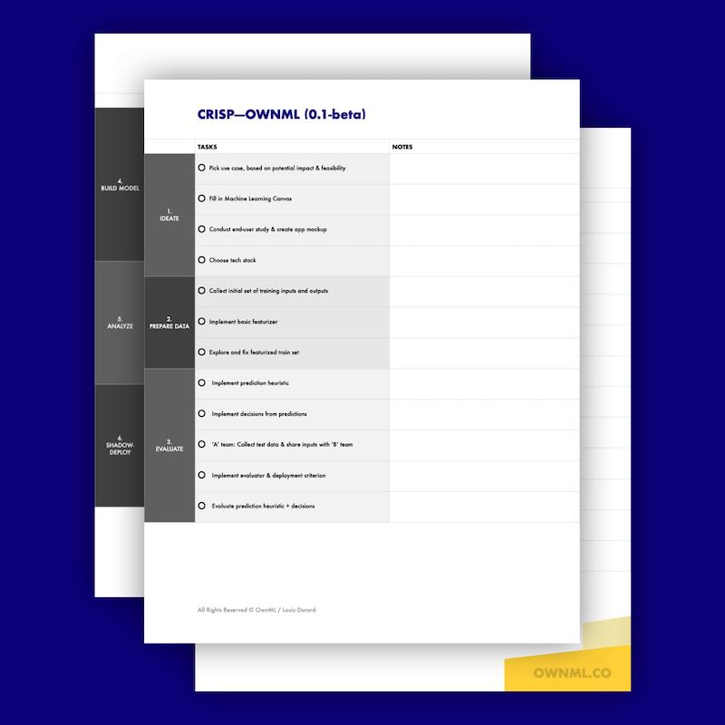

# 

# [Ready for the next step? Check out the ML Project Checklist!](https://members.ownml.co/plans/126175?bundle_token=e8fb7a30ce112af6170881728e0484d8)

Lead ML implementation with confidence with the CRISP—OWNML methodology (*Cross-Industry Standard Process to create your own Machine Learning system*) and its checklist. End-to-end ML projects are broken down into **9 phases of 4-5 tasks each**.

The checklist serves as a roadmap, listing in detail what you need to do, and in which order, so you can minimize risks and **make the most efficient use of your (and your team’s) time**.

Learn more at [**ownml.co/checklist**](https://www.ownml.co/checklist)